NAMA: Echa Apriliyanto

NIM: 5220411272

FAKULTAS: Sains dan Teknologi

PRODI: Informatika

KELAS: Pemrograman Berorientasi Objek Praktik (VII)

RUANGAN: L.K 2.3

TEMA: Seni dan Budaya

SISTEM MANAJEMEN TARI

1. Class Diagram

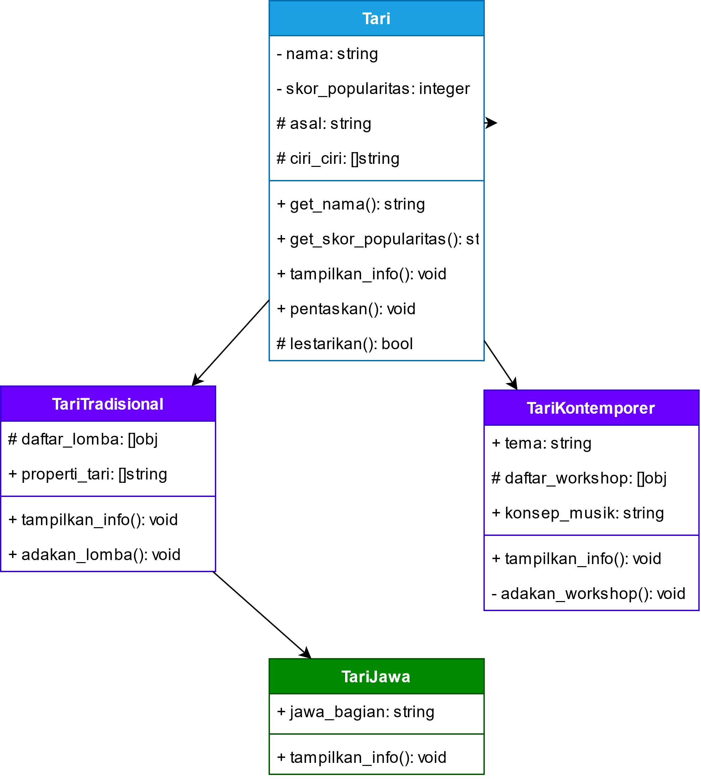

2. Kode program

"""

SISTEM MANAJEMEN TARI

"""

import random

class Tari:

    def __init__(self, nama, skor_popularitas, asal, ciri_ciri):

        self.__nama = nama

        self.__skor_popularitas = skor_popularitas

        self._asal = asal

        self._ciri_ciri = ciri_ciri

    def get_nama(self):

        return self.__nama

    def get_skor_popularitas(self):

        return self.__skor_popularitas

    def tampilkan_info(self):

        print("===== Informasi Tari =====")

        print("Nama: ", self.__nama)

        print("Skor Popularitas: ", self.__skor_popularitas)

        print("Asal: ", self._asal)

        print("Ciri-ciri: ", self._ciri_ciri)

    def pentaskan(self):

        print(f"{self.get_nama()} sedang dipentaskan")

        self.__skor_popularitas += random.randint(1, 100)

    def _lestarikan(self):

        print(f"{self.get_nama()} sedang dilestarikan")

        keberhasilan = random.randint(1, 10)

        if keberhasilan > 5:

            self.__skor_popularitas += keberhasilan

            print(f"{self.get_nama()} berhasil dilestarikan!")

            return True

        else:

            print(f"Upaya pelestarian {self.get_nama()} gagal!")

            return False

class TariTradisional(Tari):

    def __init__(self, properti_tari, nama, skor_popularitas, asal, ciri_ciri):

        super().__init__(nama, skor_popularitas, asal, ciri_ciri)

        self._daftar_lomba = []

        self.properti_tari = properti_tari  # list

    def tampilkan_info(self):

        super().tampilkan_info()

        print("Properti Tari: ", self.properti_tari)

        print("Daftar Lomba Yang Pernah Diadakan: ")

        for i in range(len(self._daftar_lomba)):

            print(f"    {i + 1}. ", self._daftar_lomba[i])

    def adakan_lomba(self, judul_lomba, tanggal, lokasi):

        lomba = {"judul_lomba": judul_lomba, "tanggal": tanggal, "lokasi": lokasi}

        self._daftar_lomba.append(lomba)

        print(f"Lomba {judul_lomba} berhasil diselenggarakan!")

class TariKontemporer(Tari):

    def __init__(self, tema, konsep_musik, nama, skor_popularitas, asal, ciri_ciri):

        super().__init__(nama, skor_popularitas, asal, ciri_ciri)

        self.tema = tema

        self.konsep_musik = konsep_musik

        self._daftar_workshop = []

    def tampilkan_info(self):

        super().tampilkan_info()

        print("Tema: ", self.tema)

        print("Konsep Musik: ", self.konsep_musik)

        print("Daftar Workshop Yang Pernah Diadakan: ")

        for i in range(len(self._daftar_workshop)):

            print(f"    {i + 1}. ", self._daftar_workshop[i])

    def __adakan_workshop(self, judul_workshop, tanggal, lokasi):

        workshop = {

            "judul_workshop": judul_workshop,

            "tanggal": tanggal,

            "lokasi": lokasi,

        }

        self._daftar_workshop.append(workshop)

        print(f"Workshop {judul_workshop} berhasil diselenggarakan!")

class TariJawa(TariTradisional):

    def __init__(

        self, jawa_bagian, properti_tari, nama, skor_popularitas, asal, ciri_ciri

    ):

        super().__init__(properti_tari, nama, skor_popularitas, asal, ciri_ciri)

        self.jawa_bagian = jawa_bagian

    def tampilkan_info(self):

        super().tampilkan_info()

        print("Jawa Bagian: ", self.jawa_bagian)

tari_jaipong = TariTradisional(

    ["Kipas", "Selendang"],

    "Tari Jaipong",

    100,

    "Jawa Barat",

    "Gerakan yang dinamis namun lemah gemulai",

)

korean_dance = TariKontemporer(

    "Korea",

    "Musik K-Pop",

    "Korean Dance",

    100,

    "Korea",

    "Gerakan yang dinamis dan lincah",

)

tari_topeng = TariJawa(

    "Jawa Barat",

    ["Topeng", "Kipas"],

    "Tari Topeng",

    100,

    "Jawa Barat",

    "Gerakan yang gagah dan dinamis",

)

print("=" * 70)

for tari in [tari_jaipong, korean_dance, tari_topeng]:

    tari.pentaskan()

    print()

    tari._lestarikan()

    print()

    if isinstance(tari, TariTradisional):

        for _ in range(random.randint(3, 5)):

            lomba_ke_n = random.randint(1, 10)

            while lomba_ke_n in [lomba["judul_lomba"] for lomba in tari._daftar_lomba]:

                lomba_ke_n = random.randint(1, 10)

            tari.adakan_lomba(

                f"Lomba {tari.get_nama()}-{lomba_ke_n}",

                f"{random.randint(1,31)}-{random.randint(1,12)}-202{random.randint(1,5)}",

                "DKI Jakarta",

            )

        print()

    elif isinstance(tari, TariKontemporer):

        for _ in range(random.randint(3, 5)):

            workshop_ke_n = random.randint(1, 10)

            while workshop_ke_n in [

                workshop["judul_workshop"] for workshop in tari._daftar_workshop

            ]:

                workshop_ke_n = random.randint(1, 10)

            tari._TariKontemporer__adakan_workshop(

                f"Workshop {tari.get_nama()}-{workshop_ke_n}",

                f"{random.randint(1,31)}-{random.randint(1,12)}-202{random.randint(1,5)}",

                "DKI Jakarta",

            )

        print()

for tari in [tari_jaipong, korean_dance, tari_topeng]:

    tari.tampilkan_info()

    print("")

3. Screenshot Hasil Running Program



